BUILDING A SMARTER AI POWERED SPAM CLASSIFIER

TEAM MEMBER

NIJANTH DERIXON A

PHASE 5

SUBMISSION DOCUMENT

TOPIC:BUILDING A SMARTER AI POWERED SPAM CLASSIFIER

INTRODUCTION

Building a smarter AI-powered spam classifier is a critical endeavor in today's digital age where spam messages inundate our communication channels. Spam filters play a pivotal role in safeguarding user experience, privacy, and information security. To develop a more effective spam classifier, a comprehensive approach is needed, involving advanced artificial intelligence techniques, data preprocessing, feature engineering, and continuous learning. In this introduction, we'll outline the key components and steps in the process of building a smarter AI-powered spam classifier.

- Understanding the Problem:

Spam, in the context of emails, text messages, or other digital communication, refers to unsolicited, irrelevant, or harmful content. A smarter AI-powered spam classifier aims to differentiate between legitimate and spam messages, enhancing the accuracy of classification.

- Data Collection:

To build a robust spam classifier, it is crucial to collect a diverse and representative dataset of both spam and non-spam (ham) messages. This dataset serves as the foundation for training and evaluating the AI model.

- Data Preprocessing:

Data cleaning and preprocessing are essential to remove noise, standardize formats, and extract relevant features from the text data. This step prepares the data for machine learning.

- Feature Engineering:

Feature engineering involves the extraction and selection of discriminative features from the text. Features can include word frequencies, n-grams, sender information, and more. Careful feature engineering contributes significantly to the model's performance.

- Model Selection:

Choosing the appropriate machine learning or deep learning model is crucial. Common choices include Naive Bayes, Support Vector Machines, Random Forests, or more advanced models like recurrent neural networks (RNNs) or transformers.

- Training the Model:

The model is trained on the labeled dataset, learning to distinguish spam from non-spam messages. It should be capable of generalizing well to unseen data.

- Evaluation and Validation:

The classifier's performance is assessed using metrics like precision, recall, F1-score, and accuracy. Cross-validation techniques are often employed to ensure robustness.

- Hyperparameter Tuning:

Optimizing hyperparameters and fine-tuning the model is essential to achieve the best possible results. This may involve adjusting learning rates, batch sizes, or architectural choices.

- Continuous Learning and Adaptation:

Spammers continually evolve their tactics. To stay effective, the spam classifier must continuously learn from new data and adapt its rules and features. Regular model retraining is essential.

- User Feedback Loop:

Incorporate user feedback to improve the classifier. Users can report false positives and false negatives, helping the system adapt and reduce errors over time.

- Integration into Systems:

The spam classifier should be seamlessly integrated into email clients, messaging apps, or other communication platforms, ensuring that users have a spam-free experience.

- Monitoring and Maintenance:

Continuous monitoring is necessary to detect any deviations in spammer behavior. Regular maintenance, updates, and security enhancements are crucial to keep the system effective.

Building a smarter AI-powered spam classifier is a dynamic process that requires a multidisciplinary approach, involving data science, machine learning, and cybersecurity expertise. As the digital landscape evolves, the need for a sophisticated spam filter becomes even more pronounced, making this an area of ongoing research and development.

DATA SET LINK : https://www.kaggle.com/datasets/grafstor/simple-dialogs-for-chatbot

GIVEN DATA SET

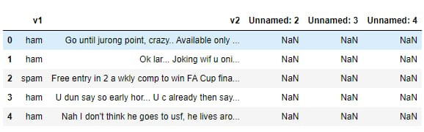

NECESSARY STEPS TO FOLLOW

- IMPORT LIBRARIES:

Start by improving the necessary libraries

PROGRAM:

%matplotlib inline
import matplotlib.pyplot as plt
import csv
import sklearn
import pickle
from wordcloud import WordCloud
import pandas as pd
import numpy as np
import nltk
from nltk.corpus import stopwords
from sklearn.feature_extraction.text import CountVectorizer, TfidfTransformer
from sklearn.tree import DecisionTreeClassifier
from sklearn.model_selection import GridSearchCV,train_test_split,StratifiedKFold,cross_val_score,learning_curve

Loading the Dataset

data = pd.read_csv('dataset/spam.csv', encoding='latin-1')data.head()
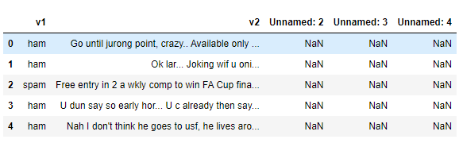

3.Removing unwanted columns
From the above figure, we can see that there are some unnamed columns and the label and text column name is not intuitive so let's fix those in this step.
data = data.drop(["Unnamed: 2", "Unnamed: 3", "Unnamed: 4"], axis=1)data = data.rename(columns={"v2" : "text", "v1":"label"})data[1990:2000]
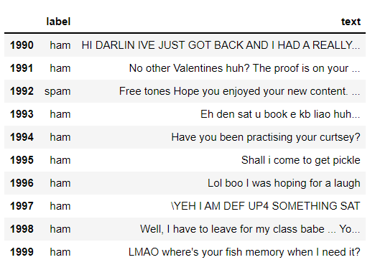
now that the data is looking pretty, let's move on.
data['label'].value_counts()# OUTPUTham 4825spam 747Name: label, dtype: int64

4.Preprocessing and Exploring the Dataset
If you are completely new to NLTK and Natural Language Processing(NLP) I would recommend checking out this short article before continuing.
import nltk packages and Punkt Tokenizer Modelsimport nltknltk.download("punkt")import warningswarnings.filterwarnings('ignore')

5.Removing punctuation and stopwords from the messages
Punctuation and stop words do not contribute anything to our model, so we have to remove them. Using NLTK library we can easily do it.
import nltk
nltk.download('stopwords')
#remove the punctuations and stopwords
import string
def text_process(text):
text = text.translate(str.maketrans('', '', string.punctuation))
text = [word for word in text.split() if word.lower() not in stopwords.words('english')]
return " ".join(text)
data['text'] = data['text'].apply(text_process)
data.head()
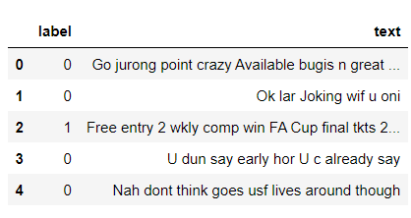
Now, create a data frame from the processed data before moving to the next step.
text = pd.DataFrame(data['text'])label = pd.DataFrame(data['label'])

IMPORTANCE OF LOADING AND DATASET

Loading and preprocessing a dataset is a critical and foundational step in data analysis, machine learning, and artificial intelligence for several important reasons:

Data Understanding: Loading the dataset allows you to familiarize yourself with its structure, contents, and format. This understanding is crucial for making informed decisions throughout the analysis process.

Data Quality Assurance: Preprocessing begins with data quality control. You can identify and rectify missing values, errors, duplicates, and inconsistencies in the data, ensuring that the analysis is based on accurate and reliable information.

Data Cleaning: Datasets are often noisy, and preprocessing helps clean the data by removing irrelevant or redundant information, making it more suitable for analysis.

Data Transformation: Different algorithms require data in specific formats. For example, text data may need to be tokenized, numerical features may require scaling, and categorical variables may need encoding. Preprocessing ensures that the data is in the right format for machine learning algorithms.

Data Consistency: Maintaining consistent data formatting, such as date formats or categorical values, streamlines the analysis and model training process, reducing errors and improving efficiency.

let's use the above functions to create Spam word cloud and ham word cloud.
spam_wordcloud = WordCloud(width=500, height=300).generate(spam_words)ham_wordcloud = WordCloud(width=500, height=300).generate(ham_words)
#Spam Word cloudplt.figure( figsize=(10,8), facecolor='w')plt.imshow(spam_wordcloud)plt.axis("off")plt.tight_layout(pad=0)plt.show()
#Creating Ham wordcloudplt.figure( figsize=(10,8), facecolor='g')plt.imshow(ham_wordcloud)plt.axis("off")plt.tight_layout(pad=0)plt.show()
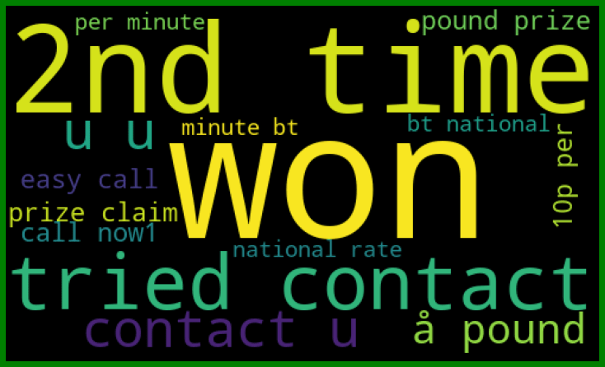
from the spam word cloud, we can see that "free" is most often used in spam.
Now, we can convert the spam and ham into 0 and 1 respectively so that the machine can understand.
data = data.replace(['ham','spam'],[0, 1])data.head(10)
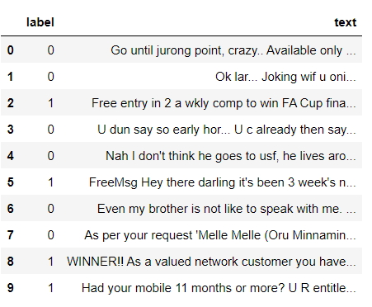

HERE IS THE LIST OF TOOLS AND SOFTWARE COMMONLY USED IN THE PROCESS

1. Programming Languages:

Python: Python is the most popular language for AI and machine learning development due to its rich ecosystem of libraries.

2.Libraries and Frameworks:

Scikit-Learn:

For traditional machine learning algorithms and pipelines.
TensorFlow and PyTorch: For building deep learning models, including neural networks.
NLTK (Natural Language Toolkit): For natural language processing and text analysis.
spaCy: Another NLP library known for its speed and accuracy.
Gensim: For topic modeling and word embeddings.

3. Data Processing and Analysis:

Pandas: For data manipulation, cleaning, and analysis.
NumPy: For numerical and array operations.
Matplotlib and Seaborn: For data visualization and plotting.

4. Feature Extraction and Engineering:

TfidfVectorizer: Term frequency-inverse document frequency vectorization for text data.
CountVectorizer: For converting text data into numerical features.

5. Model Training and Evaluation:

Jupyter Notebook: For interactive and collaborative development.
Scikit-Learn: Provides various machine learning algorithms and evaluation metrics.
Keras: High-level API for building and training neural networks.
TensorBoard: For visualizing TensorFlow models during training.

6. Machine Learning Algorithms:

Naive Bayes: A common choice for spam classification.
Support Vector Machines (SVM): Effective for binary classification tasks.
Random Forest: Useful for ensemble learning.
Deep Learning Models: Such as convolutional neural networks (CNNs) and recurrent neural networks (RNNs).

7. Data Storage and Retrieval:

SQL Databases (e.g., MySQL, PostgreSQL): For storing and managing training data.
NoSQL Databases (e.g., MongoDB): For scalable data storage.
Elasticsearch: To index and search through large datasets.

8. Deployment and Integration:

Flask or Django: For building web APIs to serve the spam classifier.
Docker: For containerizing the application and ensuring consistent deployment.
Messaging Platforms (e.g., SMTP, SMS): For real-time spam detection in communication systems.

9. Continuous Learning and Adaptation:

Apache Kafka: For streaming data and real-time model updates.
Airflow: To automate workflows, including periodic model retraining.

10. User Feedback and Reporting:

User Interface (UI) Frameworks (e.g., React, Angular): To create user-friendly interfaces for reporting spam.
Email Reporting Systems: To gather feedback from email users.

11. Cloud Services:

Amazon Web Services (AWS), Google Cloud Platform (GCP), Microsoft Azure: For scalable cloud-based machine learning and deployment.

12. Version Control:

Git: For version control and collaboration on code.

13. Monitoring and Logging:

ELK Stack (Elasticsearch, Logstash, Kibana): For centralized logging and monitoring.
These tools and software are commonly used in various stages of building and deploying AI-powered spam classifiers. Depending on the specific requirements and the architecture chosen, you may select different combinations of tools to develop an effective and adaptive spam filter.

LOADIND AND PREPROCESSING THE DATASET

Loading and preprocessing the dataset is one of the initial and critical steps in building a spam classifier. Here are the steps involved in this process:

1. Dataset Collection:

Collect a diverse and representative dataset that contains labeled examples of both spam and non-spam (ham) messages. This dataset will serve as the foundation for training and evaluating your spam classifier.

2. Data Format:

Ensure that the dataset is in a format that can be easily processed. For text data, common formats include CSV, JSON, or plain text files.

3. Data Exploration:

Load the dataset and perform initial data exploration to understand its structure, such as the number of samples, distribution of classes (spam vs. ham), and the characteristics of the text data.

4. Data Cleaning:

Remove any irrelevant or noisy information from the dataset, such as duplicate messages, special characters, or formatting issues. Cleaning helps improve the quality of the data.

5. Text Preprocessing:

Text data should undergo several preprocessing steps, including:
Lowercasing: Convert all text to lowercase to ensure consistency.
Tokenization: Split text into individual words or tokens.
Stopword Removal: Eliminate common words (e.g., "and," "the," "in") that do not carry significant meaning.
Stemming or Lemmatization: Reduce words to their root form to normalize variations (e.g., "running" to "run").

6. Data Split:

Split the dataset into training, validation, and test sets. The typical split is 70-80% for training, 10-15% for validation, and 10-15% for testing. This helps in evaluating the model's performance.

7. Text Vectorization:

Convert the preprocessed text data into numerical features that machine learning models can understand. Common vectorization methods include:
Bag of Words (BoW): Represent text as a matrix of word frequencies.
Term Frequency-Inverse Document Frequency (TF-IDF): Weigh words based on their importance in the document and corpus.
Word Embeddings: Pre-trained models like Word2Vec or GloVe can capture semantic relationships in words.

8. Handling Imbalanced Data:

Check if the dataset has an imbalance in the distribution of spam and ham messages. If it is imbalanced, consider techniques like oversampling, undersampling, or generating synthetic samples to balance the classes.

9. Data Encoding:

Assign numerical labels to the spam and ham classes. Typically, spam is labeled as "1," and ham is labeled as "0."

10. Data Serialization:

Serialize the preprocessed data, which is now ready for machine learning, to a format that is easy to load and use in your chosen machine learning framework (e.g., NumPy arrays or pandas DataFrames).

11. Save Preprocessed Data:

Save the preprocessed dataset to avoid the need for reprocessing every time you work on your spam classifier. Common formats for saving data include CSV, HDF5, or Pickle.

12. Version Control:

If you're working collaboratively or iteratively, consider using a version control system like Git to track changes to your dataset and preprocessing code.
Proper dataset loading and preprocessing are essential for the success of your AI-powered spam classifier. The quality of your data and the effectiveness of your preprocessing steps significantly impact the model's accuracy and performance. Once the dataset is prepared, you can proceed to build and train your spam classification model using machine learning or deep learning techniques.

CONCLUSION

In conclusion, building an AI-powered spam classifier is a multifaceted process that involves a combination of data collection, preprocessing, model development, and ongoing maintenance. The goal of such a classifier is to enhance user experiences by effectively identifying and filtering out unwanted spam messages while allowing legitimate communication to flow seamlessly. Here are the key takeaways from the process of building an AI-powered spam classifier:

Understanding the Problem: Recognizing the importance of combatting spam and understanding the nuances of spam messages is crucial.

Data Collection: A diverse and representative dataset of spam and non-spam messages is the foundation of the classifier.

Data Preprocessing: Thorough data cleaning and text preprocessing are essential to ensure the data is in a format suitable for machine learning.

Feature Engineering: Effective feature extraction and selection help the model distinguish between spam and non-spam messages.

Model Selection: Choosing the right machine learning or deep learning model that suits the problem is critical.

Training and Evaluation: The model is trained on the dataset and evaluated using metrics to assess its performance.

Continuous Learning and Adaptation: Regular updates and continuous learning from new data are essential to keep the classifier effective.

User Feedback Loop: User feedback plays a significant role in improving the classifier's accuracy over time.

Integration: The spam classifier needs to be seamlessly integrated into communication systems, such as email clients and messaging apps.

Monitoring and Maintenance: Continuous monitoring is essential to detect evolving spam tactics, and regular maintenance keeps the system up to date and secure.

